Dare-Devil2.0

**Background**

Galvanic Vestibular Stimulation(GVS)

Galvanic vestibular stimulation is the process of sending specific electric messages to a nerve in the ear that maintains balance. There are two main groups of receptors in the vestibular system: the **three semi-circular canals**, and the two **otolith organs** (the utricle and the saccule).

Activation of vestibular afferents by a bilateral bipolar galvanic vestibular stimulus (GVS) evokes medial-lateral (ML) body sway. By applying a GVS feedback signal that is a function of measured ML head motion, the potential exists for GVS to restore a useful vestibular contribution to ML balance control in vestibular-deficient subjects who remain responsive to GVS.

It can either remove the ability of a subject with normal vestibular function to use vestibular information for balance control, or can restore the ability of a subject with bilateral vestibular loss to maintain balance in a condition requiring vestibular information for balance control.

It has long been known that a galvanic vestibular stimulus, provided by a small electrical current introduced near the inner ear’s vestibular receptors, modulates the activity of some of the vestibular afferent nerve fibers [1,2]. When GVS is applied in human subjects using a bilateral bipolar electrode configuration (current passed between electrodes located behind the two ears) an ML body sway is evoked such that subjects lean toward the side of the anodal electrode. Other electrode configurations induce anterior-posterior body sway [3], but in the present study we focus on the more robust ML induced sway evoked using the bilateral bipolar electrode configuration.

The GVS technique is very simple.

* The electrodes are now placed on the **mastoid processes** rather than in the ears.
* The stimulus is usually delivered by a controlled current source at levels of ∼1 mA.
* The stimulus is most commonly delivered with an anodal electrode on the mastoid process behind one ear and a cathodal electrode behind the other ear, i.e., bilateral bipolar GVS.
* However, other configurations are bilateral monopolar GVS with electrodes of the same polarity at both ears and a distant reference electrode and unilateral monopolar GVS with a stimulating electrode at just one ear.
* When the small current flows for 1 or 2 s, it causes a person to sway if they are standing or perceive illusory movements if they are not. The simplicity of the technique, however, belies the complexity of the body response it evokes

This technology has been investigated for both military and commercial purposes. The technology is being applied in Atsugi, Japan, the Mayo Clinic in the US, and a number of other research institutions around the world. It is being investigated for a variety of applications, including biomedical, pilot training, and entertainment.

Not much is known about galvanic vestibular stimulation, but more scientists are continuing to research the topic.

**Components Used:**

1. Two 6V Battery packs
2. BreadBoard
3. Arduino freeduino
4. Power bank
5. Arduino development software
6. Bluetooth module
7. MIT app inventor

Current Limiter Ckt

1. uA741CP IC
2. 10K Pot
3. 2N7000 n channel mosfet
4. Resistors : 220E

H-bridge

1. IRF9540N P channel Mosfet(x2)
2. IRF540N N channel Mosfet(x2)
3. 2N3904 npn transistors (x2)
4. Resistors : 1K(x2), 10K(x2),
5. Electrodes : Cellulose Sponge, Crocodile Clips, Copper plate

Electrolyte: NaCl solutions (15, 140 and 220 mM NaCl) or deionized water

**Circuit diagram**

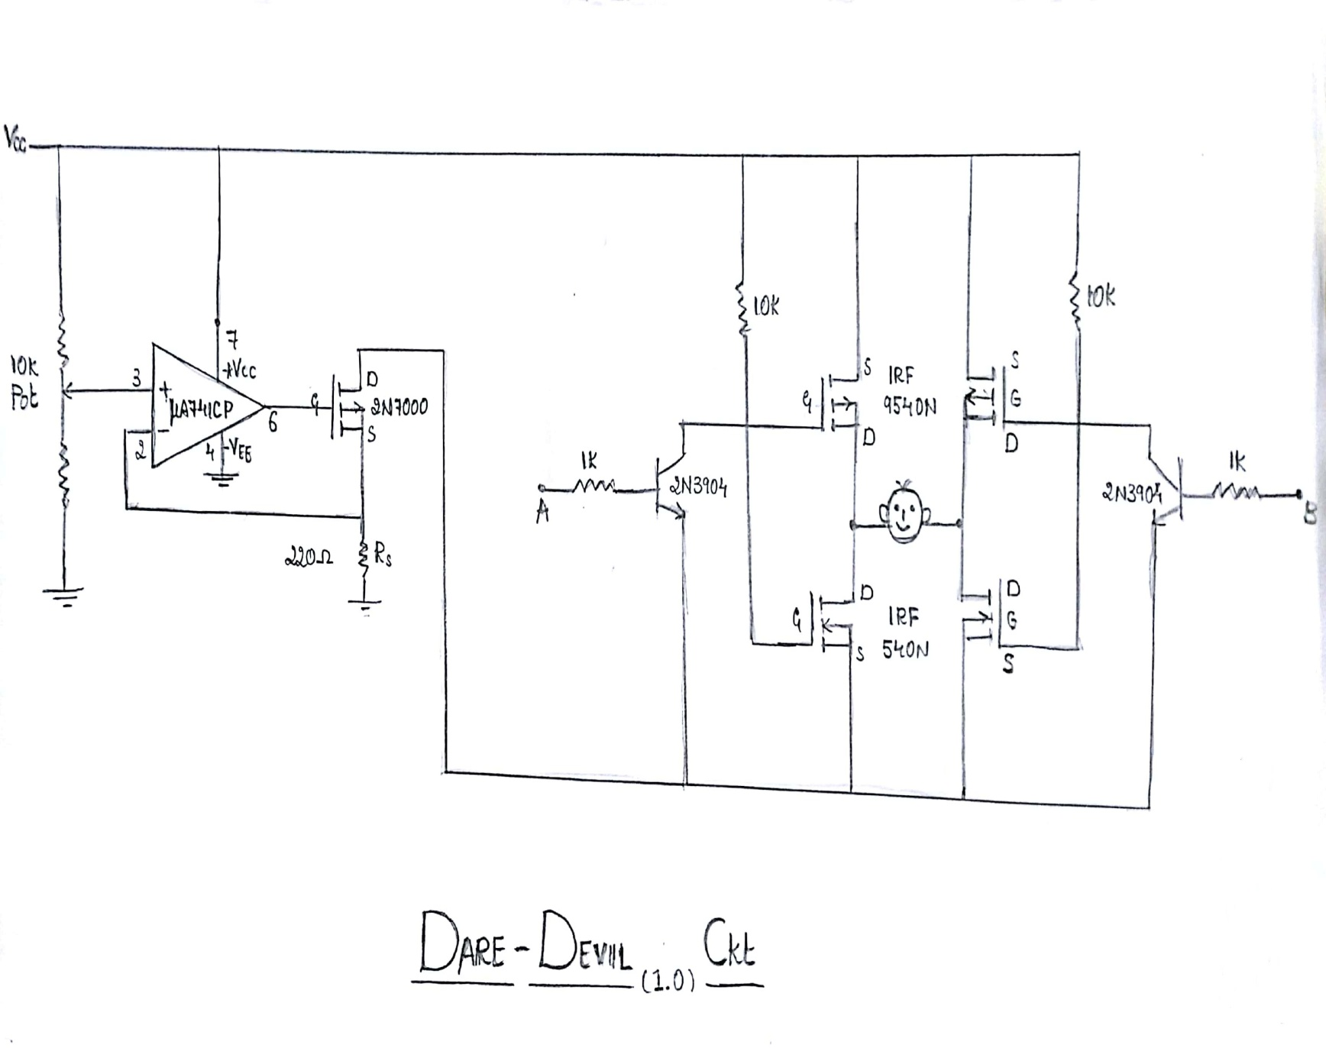

**Arduino ckt diagram**

**Arduino coding**

**App using MIT app inventer :**

**Operation**

There are 2 main Operations:

Current limiting: A variable voltage is given to the non inverting terminal of the op amp. The voltage coming out of the amplifier increases the voltage at the gate if the MOSFET and a short circuit is made from VCC to gnd through RL( H bridge ) and RS ( used to control the current to 3mA) . Now a negative feedback is given back to the non inverting terminal which reduces the output voltage to a point where the gate closes and current is stopped . The process repeats as the current goes to 3mA and 0A, and a linear current is seen because of the fast transitions of the op amp.

H bridge: it consists of two p channel MOSFETs and n channel MOSFETs, which are driven by two transistors on either side which acts as a switch. input is given to A and B ends.

The electrodes are connected between the drain of the MOSFETs combination on either side of the bridge.

There are four possible combinations for current to flow.Initially both A and B are low.Now, both transistors are in OFF condition.Hence they are act as a open circuit. Therefore both P channel MOSFETs are off and n channel MOSFETs are on.

Hence the potential difference between the electrodes is zero.When both A and B are high, both e transistors are in ON condition. Hence they acts as a short. Therefore both P channel MOSFETs are on and both n channel MOSFETs are off. As the potential difference between the electrodes will be zero so no current flows. When A is high and B is low, transistor P is On hence acts as short and the voltage at node X drops to zero. So Q1 turns ON and Q2 turns OFF.As transistor Q is OFF, it acts as open circuit. Therefore Q3 is OFF and Q4 is ON. The current can take the path from Q1, electrodes , Q3 to the ground. When A is low and B is high, transistor P is OFF hence acts as open circuit. So Q1 turns OFF and Q2 turns ON.As transistor Q is ON, it acts as a short. Therefore Q3 is ON and Q4 is OFF. The current take path from Q3, electrodes ,Q 2 to the ground.

Now the on off combinations are given to the A and B terminal through the digital out pins of the arduino. The input to the arduino is in the form of a serial communication with a android phone via a Bluetooth module. The keys pressed in the app will trigger the respective A and B terminal to turn the person either left or right.

**Applications**

* Used in clinical practice to test the functionality of the sense of balance.
* It may also help people dodge oncoming cars or direct a rescue worker in a dark tunnel.
* Developmentof an analogue of post-flight sensorimotor dysfunction in astronauts.
* GVS is suited ideally for the investigation of the vestibular cortex by means of functional imaging techniques.
* To prevent the elderly from falling and to help people with an impaired sense of balance. But the effect is also suited for games and other entertainment( Virtual Reality ).
* If the sensation of movement can be captured for playback, then people can better understand what a ballet dancer or an Olympian gymnast is doing, and that could come handy in teaching such skills.

**Acute side effects**

* Phosphene (Flashes of light)
* Metallic taste in mouth
* Stinging under electrodes
* Dizziness and nausea
* Land legs

**NOTE**: The very low level of electricity required for the effect is unlikely to cause any health damage.

**Future Endeavor**

* Finding the right way to deliver an electromagnetic field to the ear at a distance could turn the technology into a weapon for situations where "killing isn't the best solution.

This would be the most logical situation for a nonlethal weapon that presumably would make your opponent dizzy. By finding the right frequency, energy, duration of application, we would hope to find something that doesn't permanently injure someone but would allow us to make someone temporarily off-balance

**We maintain that the point is not to control people against their will. If you're determined to fight the suggestive orders from the electric currents by clinging to a fence or just lying on your back, you simply won't move.**